Checklist for Written Consent: Unregistered Use of Medicine
Includes off label medicine use* or medicine available via Special Access Scheme (SAS) or Authorised Prescriber Scheme (APS)**
- Consent is a process - not a piece of paper.

- Consent can be withdrawn at any time.

- Do not use abbreviations as these may not be understood.

- For people under 16 years of age or those aged over 16 who do not have capacity to give consent, consent must be obtained from the Parent/Guardian or Person Responsible, respectively. They should provide their signature, printed name, address, phone number, and relationship to patient/ reason for representation. Effort should be made to include the person (patient) in the decision-making and consent processes.

- Use a Health Care Interpreter (not family member) when the person is not fluent in English. Provide details of interpreted language, interpreter name and signature, employee ID/provider number and date and time.

*Off-label use of a medicines describes the use of a TGA-registered product in ways other than those specified in the Australian TGA product information and may include medicine use for a non-approved indication, at a different dose, via an alternate route or for a patient whose age or gender is outside the registered use. In general, off-label use should only be considered when the TGA-approved use of a registered medicines does not address the clinical needs of a patient.
Because these medicines are being used outside their approved (registered) use, written informed consent with documented reasons for use is required. (The one exception is for routine off-label use where the usual process for consent is applicable - see CATAG Guiding Principles for quality use of off-label medicines for further information.)
**SAS or APS: In certain circumstances, unregistered medicines may be obtained via the Special Access Scheme or Authorised Prescriber Scheme. These medicines will not have been evaluated for quality, safety, or efficacy in Australia by the TGA and hence require increased consent requirements. The prescriber accepts responsibility for the use of an "unapproved" therapeutic good and any associated adverse reactions.

The following should be included in the consent process and documentation for unregistered use of a medicine when using a generic consent form:
☐ Prescriber details: Name of prescriber who is providing necessary information and obtaining written consent (provide further details if prescriber and consenting clinician different).
☐ Explain:  ☐The proposed therapy- its off-label/unregistered status, what is involved/ how it will be used.  ☐What the proposed therapy will treat.  ☐The reason why other registered treatment(s) are not suitable.  ☐The expected benefits and the possible harms of the proposed therapy including the possibility of unknown and/or late side effects. | ☐ Ask:  ☐Is there anything else the patient/ Person Responsible would like to know?  ☐Is there anything else patient/ Person Responsible does not understand? | ☐ Provide written information
☐ Document the consent process as per local policy including the declaration from the patient or person responsible that they have understood the explanations for use including the nature and risks of off-label/unregistered use, had opportunity to ask questions, are satisfied with the answers and agree to receive the medicine.
Include signatures of patient/person responsible, witness (and name), consenting clinician and interpreter, if applicable.

Further information: NSW Health Consent to Medical and Healthcare Treatment Manual (Consent Manual)
An example of a Consent Form for Unlicensed Use of Medication is provided below.

Example: Consent Form for Unlicensed Use of Medication (page 1), with acknowledgements to NSLHD
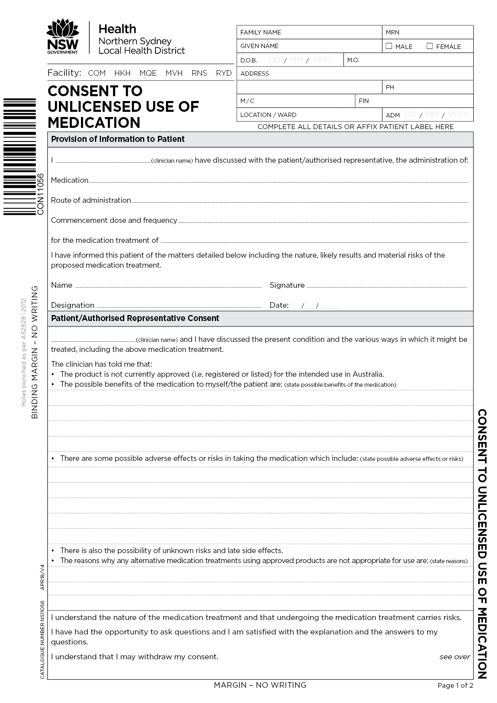

EXAMPLE

EXAMPLE

Example: Consent Form for Unlicensed Use of Medication (page 2), with acknowledgements to NSLHD
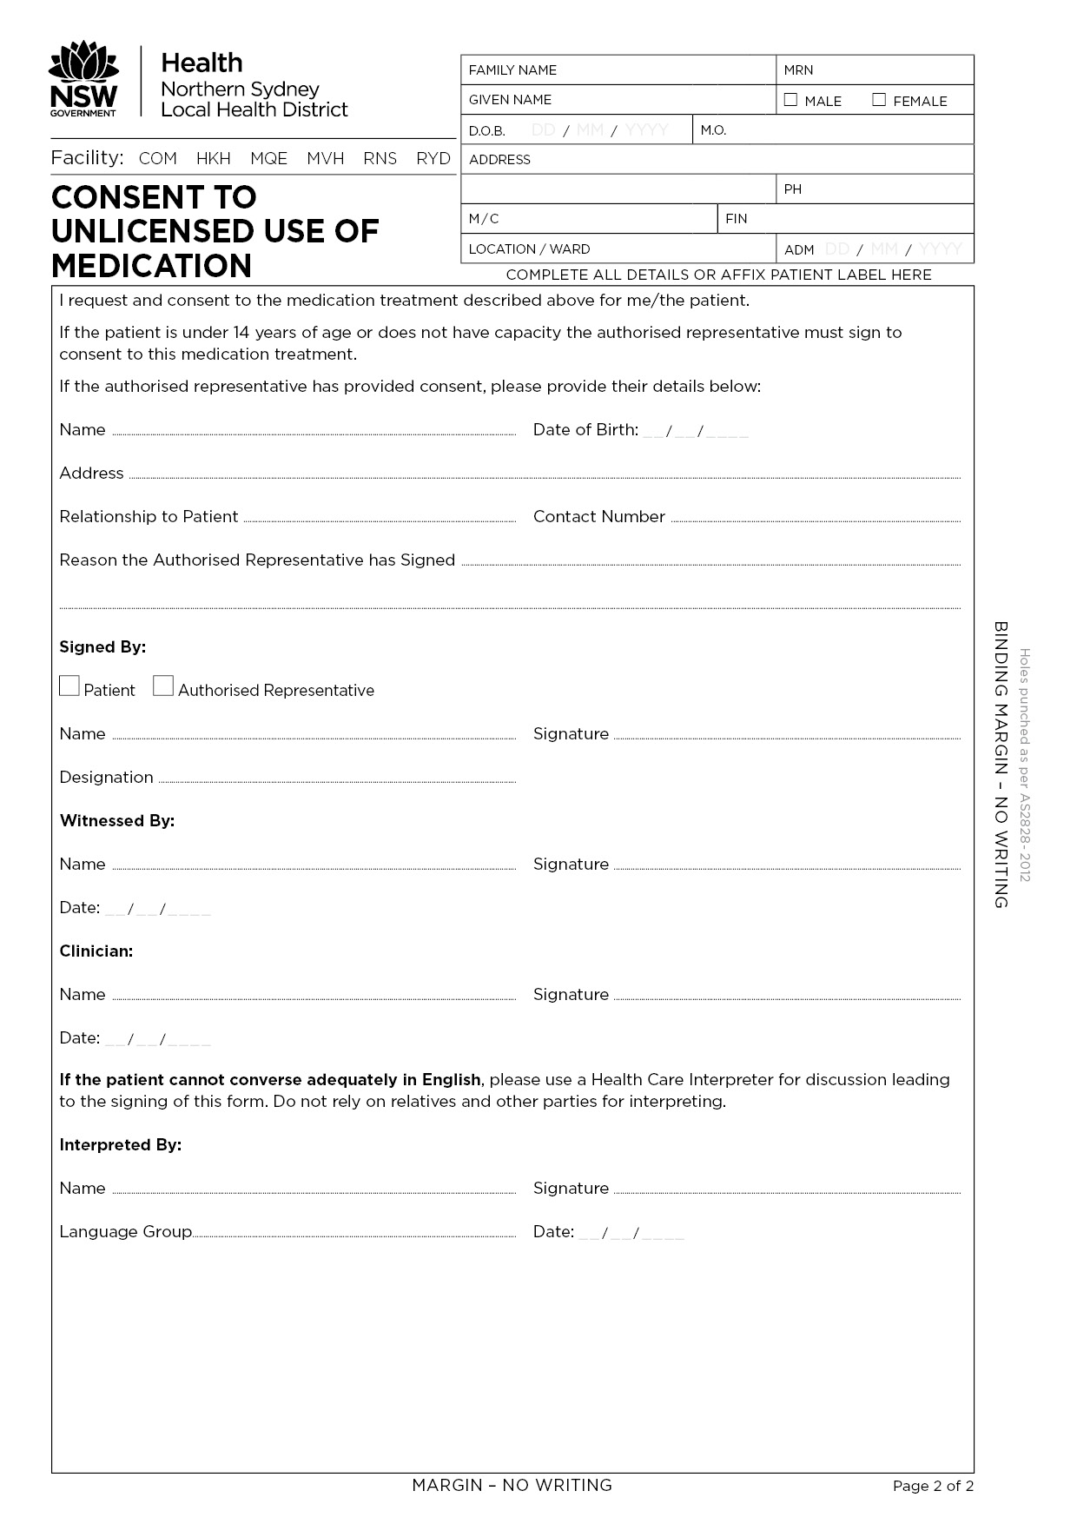

EXAMPLE

EXAMPLE

